**Cloud Computing Lab - 3**

Simulate the cloud analyst environment as per the following specification :

Create 4 dc in continents north america,asia,africa,australia with 50 Ub in respective continents. Ub should have 100 user grouping factor and 100 request grouping factor in DCs with executable instruction length 150 per request(byte) with following load balancing policies.:-

a. Round robin

b. equally spread current execution load

c. throttle

Prepare a graph based on the avg respomse time for this load balancing policy for the same pecification by selecting different service broker policy.

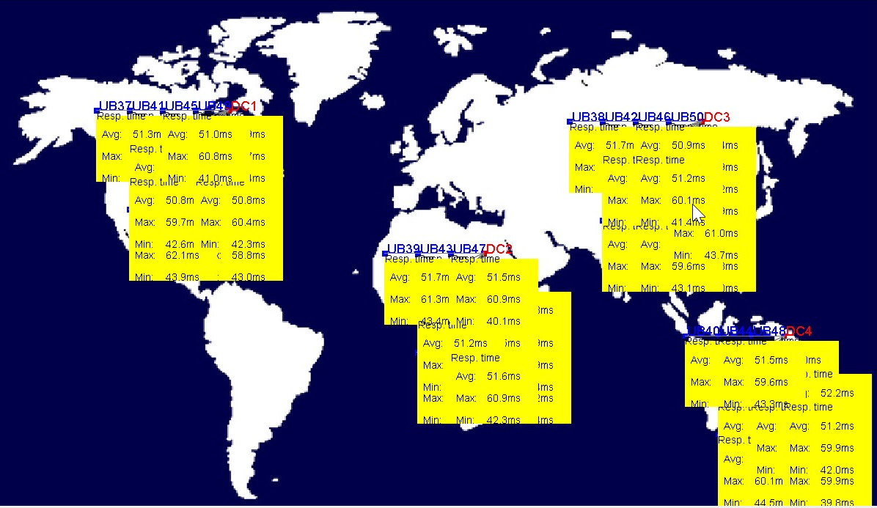

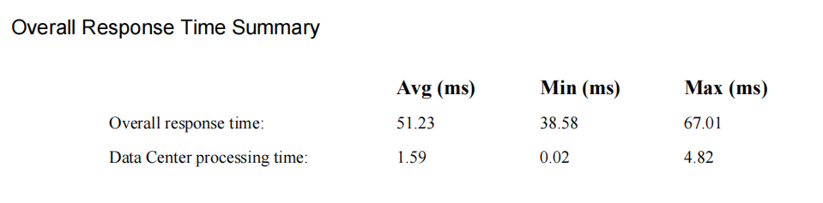

**Closest Data Center - Round Robin**

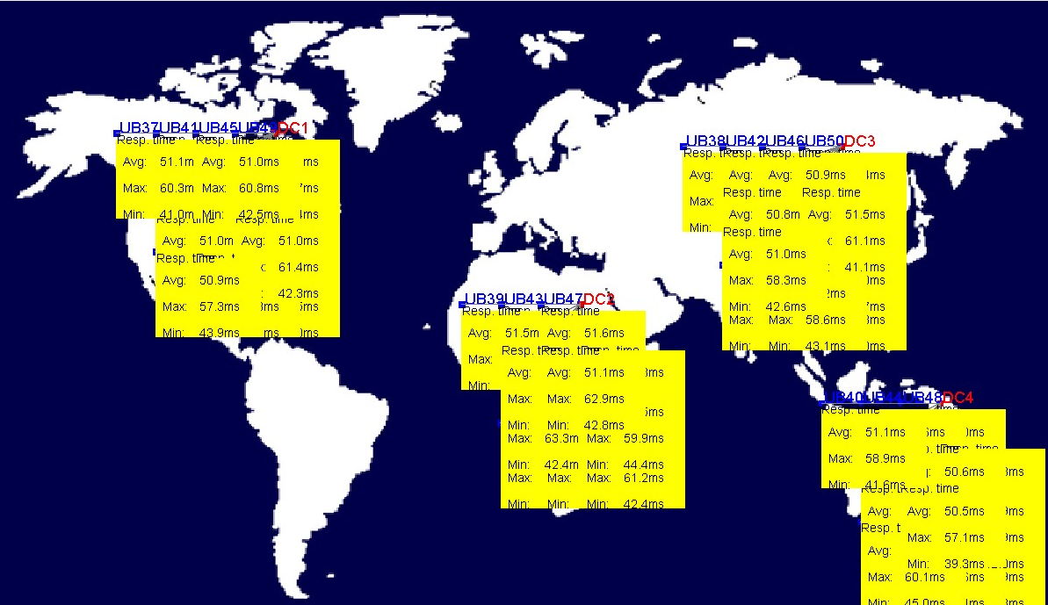

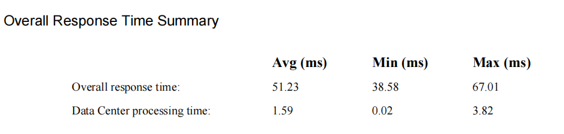

**Closest Data Center - Equally spread current execution load**

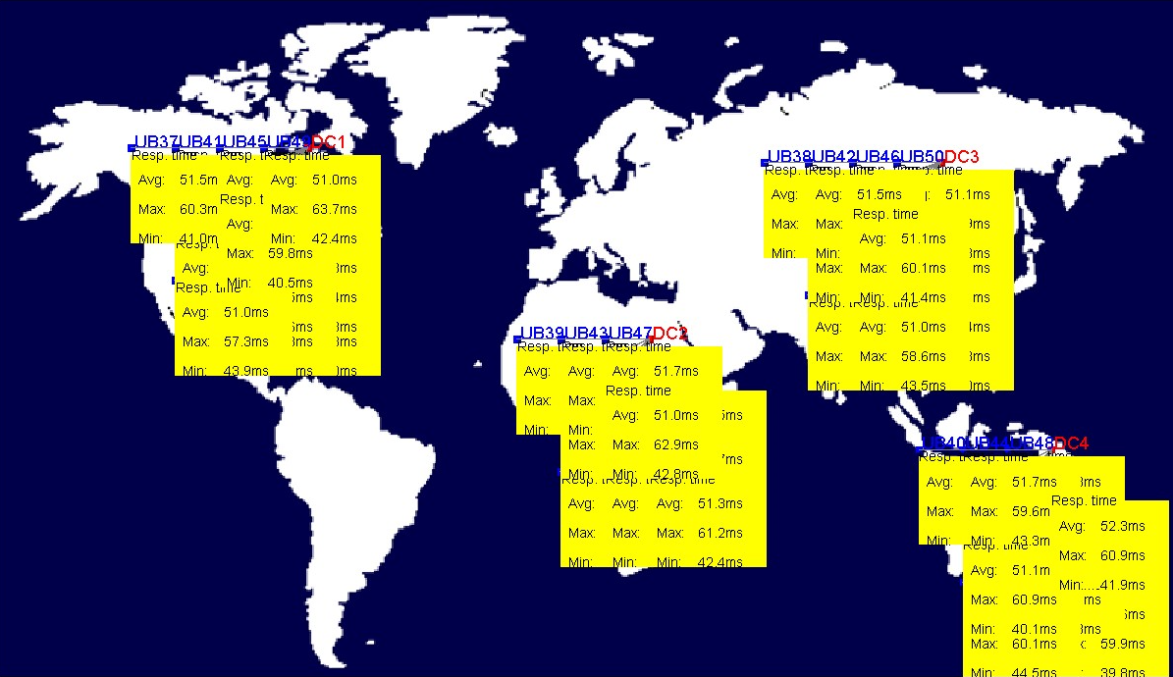

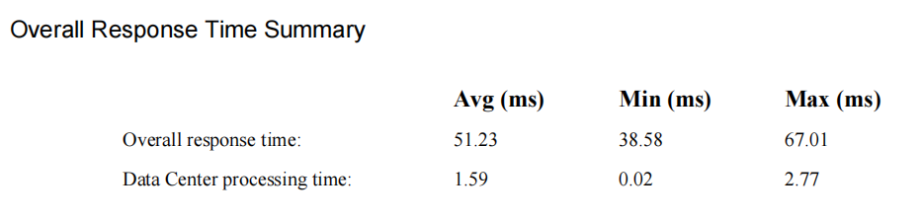

**Closest Data Center - Throttled**

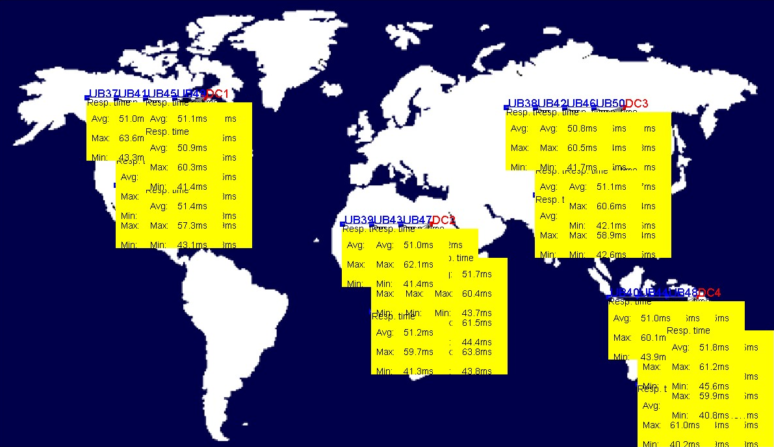

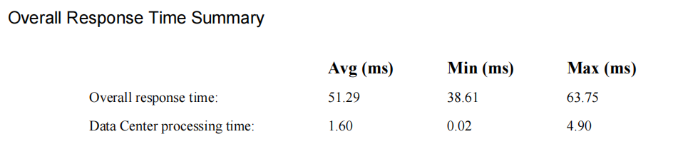

**Optimal Data Center - Round Robin**

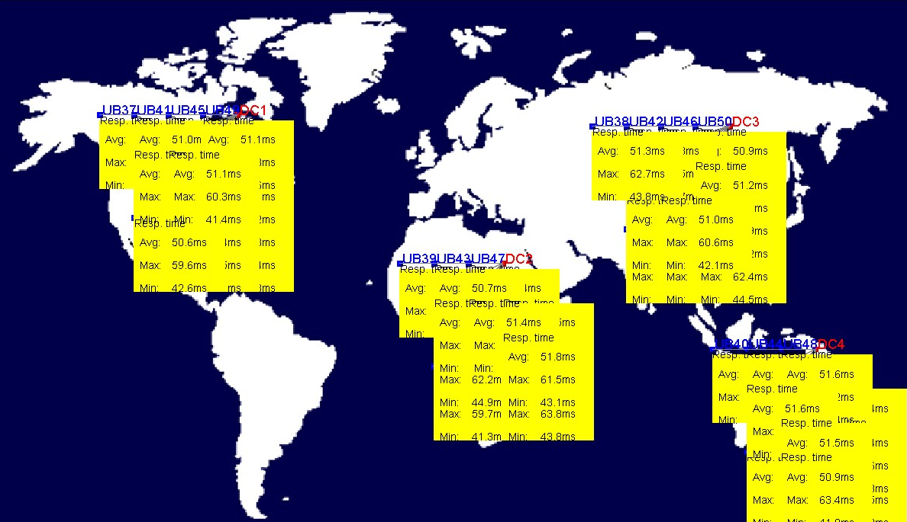

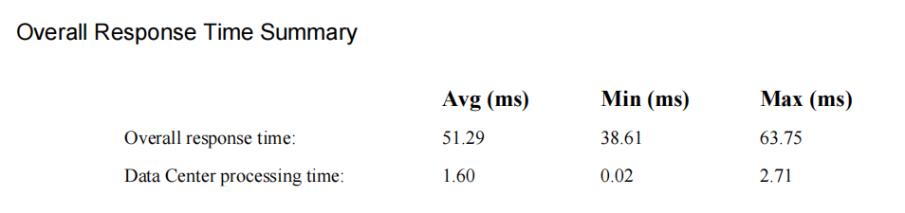

**Optimal Data Center - equally spread current execution load**

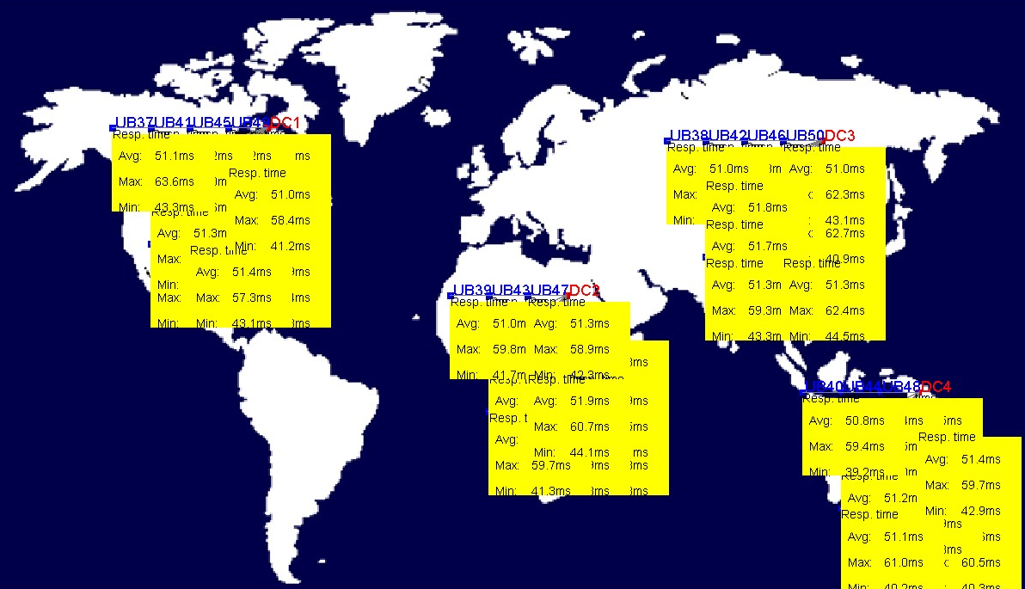

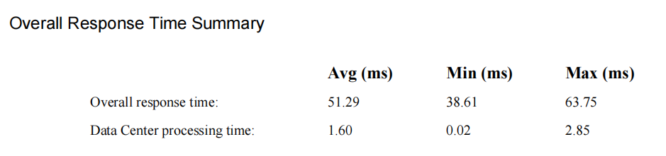

**Optimal Data Center - Throttled**

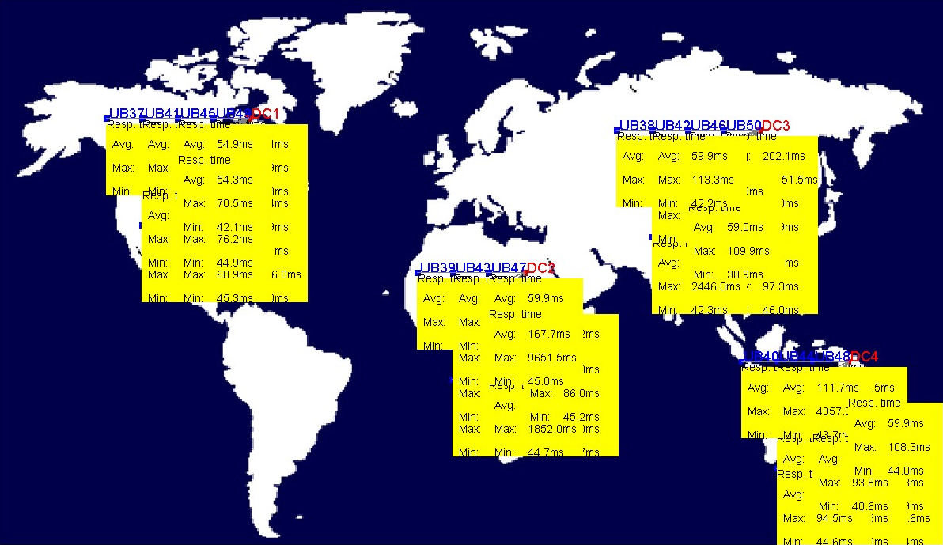

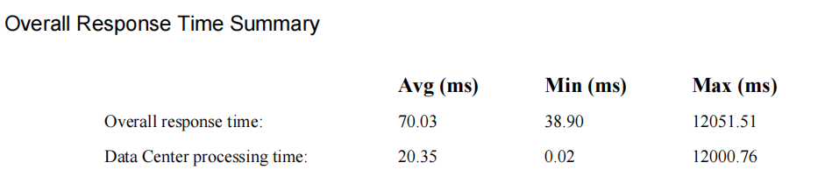

**Dynamic Data Center - Round Robin**

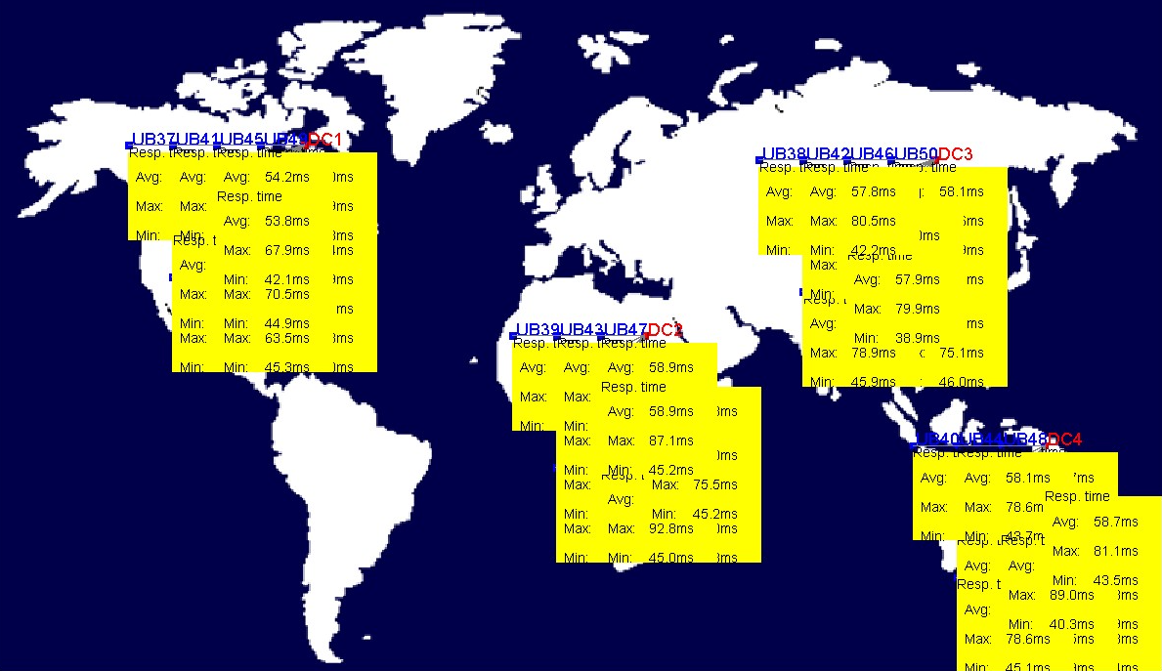

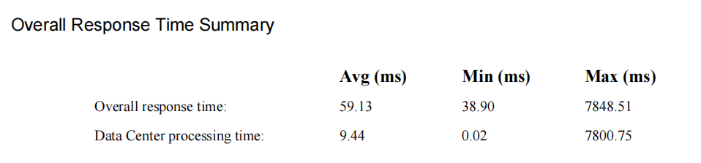

**Dynamic Data Center - equally spread current execution load**

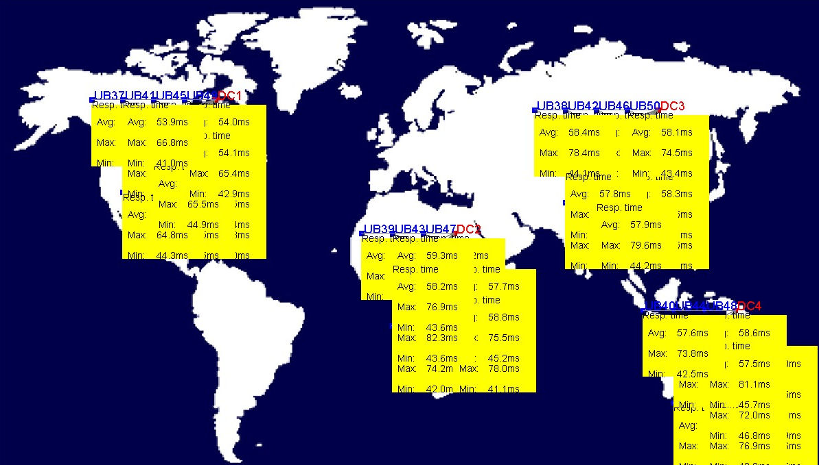

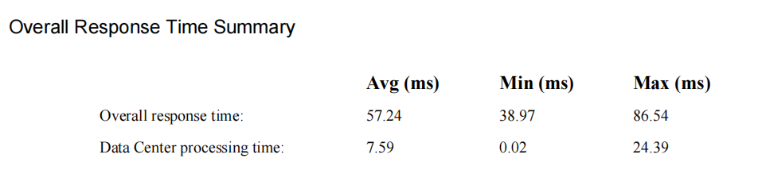

**Dynamic Data Center - Throttled**

**Final Graph**

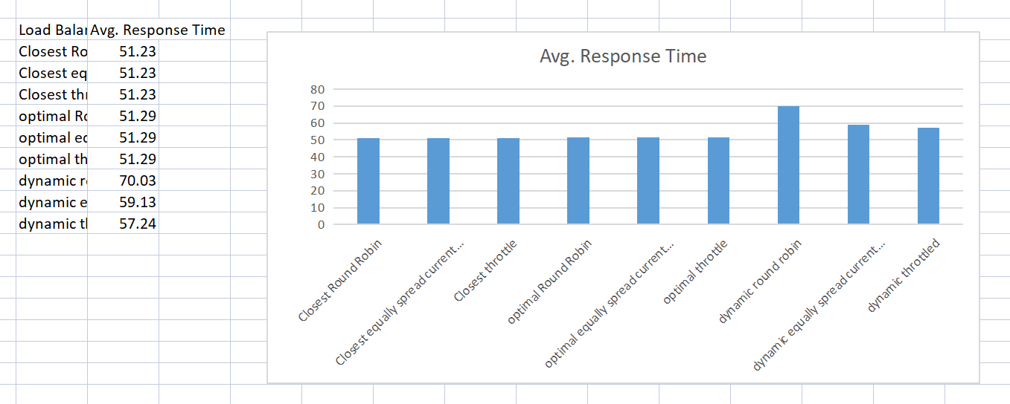

Name : Anshul Singla

Roll No. : 20051562

Section : CSE-01